
Find us also on:

The Truth Recovery Independent Panel has been appointed by the Executive Office to carry out an independent investigation.

We wish to to hear from:

Any person who has been directly impacted Relatives of those directly impacted
Any person who has worked, volunteered in, or lived in close proximity to one of these institutions

Can you help? Please get in touch:

Address:
Truth Recovery Independent Panel, 4th Floor, Equality House 7 - 9 Shaftesbury Square, Belfast, BT2 7DB

Phone: 028 9052 0263 (Open Monday – Friday 11am - 12pm and 3pm - 4pm or leave a voicemail on our secure answering service any time outside of these hours.)
Email: testimony@independentpanel.org.uk

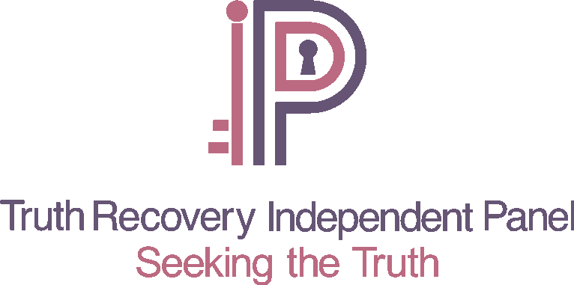
Website: www.independentpanel.truthrecoveryni.co.uk

